# Integrating the Autoaddress Plugin for WooCommerce

## Requirements

The following are prerequisites to implement the plugin:

1. A WordPress website with the WooCommerce plugin installed.
2. The Autoaddress Plugin which can be downloaded from [here](https://api.autoaddress.ie/2.0/plugins/woocomerce).
3. An Autoaddress Licence Key, contact [sales@auoaddress.ie](mailto:sales@auoaddress.ie) to get a developer key.

## Implementation

This document demonstrates how to use the HTML object to insert the Autoaddress control into your WordPress website. Please follow the steps below:

### Step 1. Download the plugin

* Download the plugin “**autoaddress-address-lookup.zip**” from GitHub [here](https://api.autoaddress.ie/2.0/plugins/woocomerce)
* Save the file locally

### Step 2. Upload the plugin

* Log in to your WordPress website
* On the Admin Dashboard, select [Plugins]
* Select [Add New]

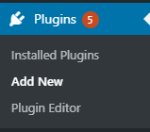

* Click the “Upload Plugin” button
* Click the [Choose File] button and select the “**autoaddress-address-lookup.zip**” file downloaded in Step 1
* 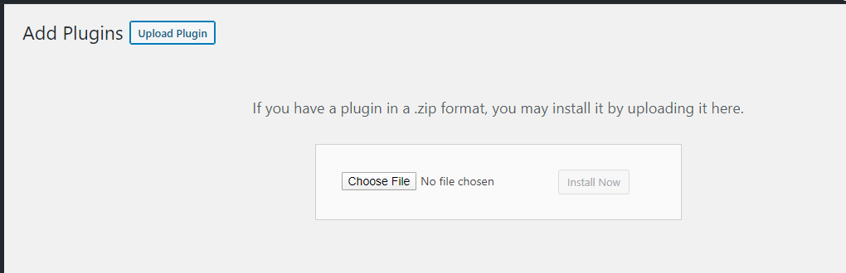Remember to click the [Activate] button that appears after upload

### Step 3. Configure the plugin

Once the installation is complete and the plugin activated, you will see “Autoaddress” as an item in the Admin dashboard.

* Click on the “Autoaddress” item to open the General Settings form

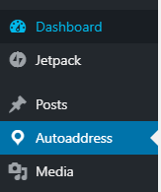

* The General Setting page has several settings, all of which will be pre-populated except the Licence Key. Populate with the Licence Key received from Autoaddress
* The [Billing Address] and [Shipping Address] fields represent the HTML element ID’s. They are prepopulated with the values from the standard WooCommerce Checkout page, but can be edited
* The [Profile Name] field represents a profile provided by Autoaddress. A profile is a means of formatting the address returned by Autoaddress. The default profile should be fine for the majority of users, but if you have special address format requirements, please contact [support@autoaddress.ie](mailto:support@autoaddress.ie)

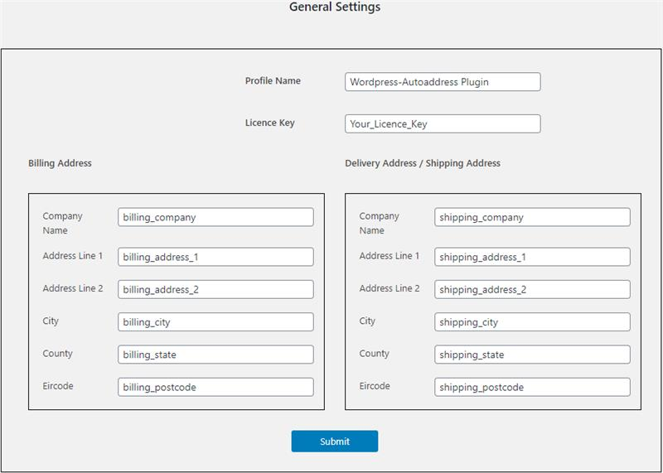

* Remember to refresh the checkout page after you have made updates to General Settings.

### Step 4. Add the plugin to your Checkout Page

* Navigate to the [Pages] menu item and
* Click [Edit] on the Checkout page

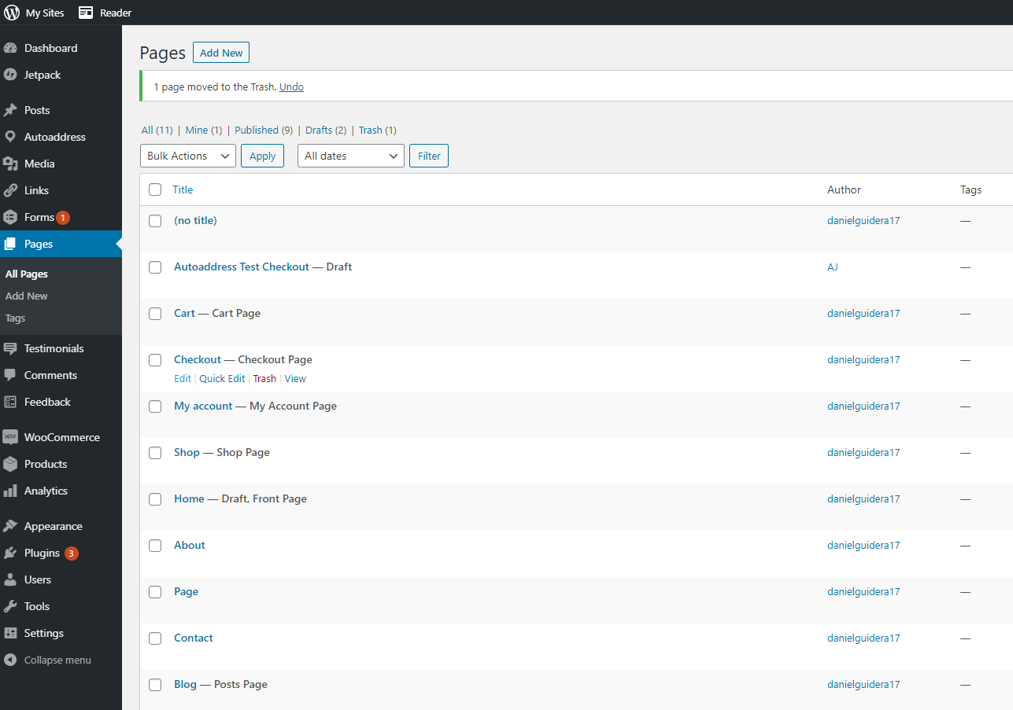

* To add the control to the billing section of your page, add the following (without the quotes): “**[autoaddress_addresslookup_billing]**”
* If you also require a control for the shipping address, add the following (without the quotes): “**[autoaddress_addresslookup_shipping]**”

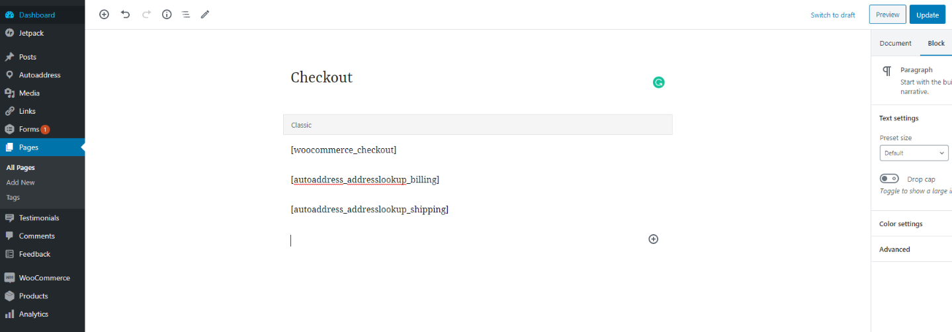

* That’s it! Just click the [Preview] button on the top right corner of the page to see exactly what your page will look like.

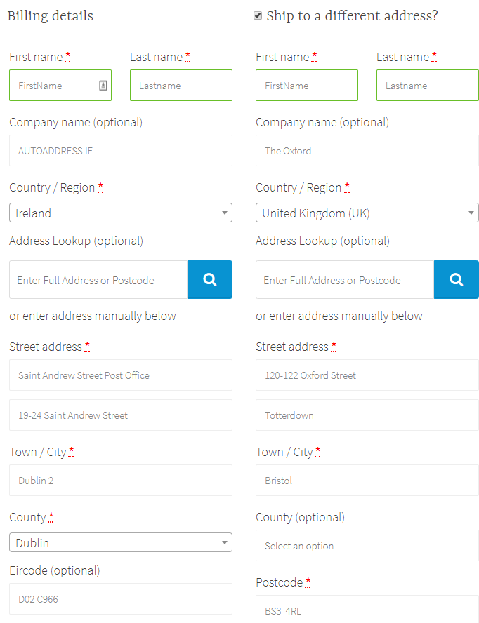

## Troubleshooting

If on test, you receive an error message relating to the licence key, as shown below, it means that you have not entered a licence key or entered and invalid one.

Be sure to obtain a valid key from [sales@autoaddress.ie](mailto:sales@autoaddress.ie) and enter it on the General Settings page as described in Step 3 above.

